Invitation to 840 Martinez Art Association Email Members
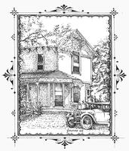

Join Us for the 8th Annual
Martinez Historical Society
Home Tour October 11, 2014 from 10 am to 4 pm

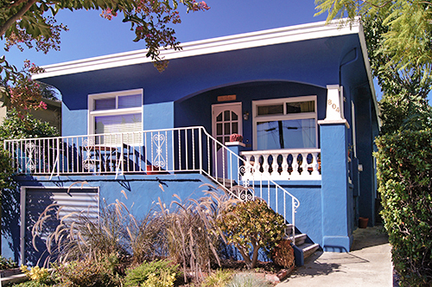
"Vivid colors both outside and inside are the theme in this house. Owned by a downtown business woman, the 1928 house melds features and furnishings from both halves of the 20th Century. An outstanding feature from the first half is a charming vintage kitchen with a beautiful Wedgewood stove -- complete with matching salt and pepper shakers."
The eighth annual Martinez Historical Society Home Tour will be conducted on Saturday, October 11, 2014 from 10 am to 4 pm. There will be seven (7) homes new to the tour. This year features a restored Craftsman home so noteworthy that it was featured in the Winter 2013 issue of American Bungalow. Also featured will be the residence of the Mayor of Martinez. An added feature this year will be the inclusion of the historic 1930 Masonic Temple on the Tour. For more information please visit the website: martinezhometour.com
Tickets for this event are $25 in advance and $30 at the door. They can be purchased at eventbrite.com (via credit card) or from the following merchants for cash or check after September 1, 2014.

I've Been Framed (411 Ferry Street)
Char's Flowers (635 Main Street)
Martinez Museum (Court & Escobar Street)
Mountain Grounds (Alhambra & J Street)
Rumain's Jewelry (510 Center Avenue)
Bagel Street Café (580 Center Avenue)
The UPS Store (the Lucky Shopping Center).

Thank you to our sponsors who make the Home Tour possible:
Shell Martinez Refinery
Cole Real Estate
Shell Chemical Company
Republic Services
Shell Western States Federal Credit Union
U.S. Bank
Hagin's Automotive
Bisio / Dunivan
Dolan's Lumber, Doors & Windows
Best Western Plus John Muir Inn
State Farm Insurance, Matthew Rinn, Agent
Les Schwab Tire of Martinez
EcoMulch
City of Martinez

We look forward to having you join us. The proceeds from this event benefits the Martinez Historical Society. For more information about the rich history of Martinez, go to: martinezhistory.org

Martinez Arts Association | 411 Ferry Street, Suite C | Martinez | CA | 94553

